A000-Czech Republic- Předmostí bei Přerov -Figurine-Mammoth-27,000-24,000 BP

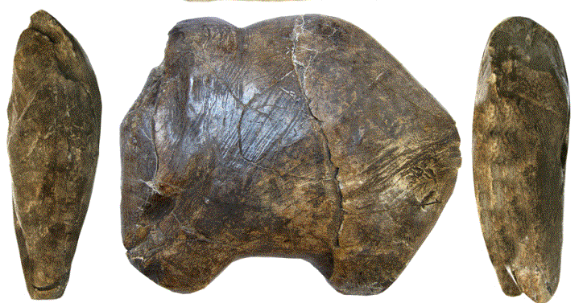

Figs. 1-3. Czech Republic- Předmostí bei Přerov -Figurine-Mammoth, replica

**Case No.: 1**

**Formal Label:** Czech Republic-Předmostí-Figurine-Mammoth

**Display Description:** This mammoth figurine carved from mammoth ivory was excavated from Předmostí bei Přerov, a cluster of three Upper Paleolithic (Gravettian) sites on limestone outcrops dating to 27,000-24,000 BP, located in Moravia, Czech Republic. The figurine is interesting because it is not meant to be a realistic portrayal but rather a snapshot of the animal in the act of foraging the tundra. It is composed of a single globular volume with carefully distinguishable stylistic features that display the animal with front feet extended forward head and trunk bent , providing an aspect of its behavior that suggests obliviousness to danger. As such, this may have been used as a pedagogical device that was intended to teach inexperienced hunters the pose of the animal when they should take aim with their atlatls.

These hunters were indeed successful at hunting mammoths and other mammals, based on the fact that the hearths within their dwellings have yielded burned bone of over 1,000 mammoths, and added to these were bones of Pleistocene mammals including fox, horse, wolf, bear, wolverine, hare, and dog, and of this latter mammal some were considered possibly domesticated by their physical anatomy (Germonpre et alii 2012). Based on this assemblage, the site was used for an extended period of time.

**Accession Number:** A000

**LC Classification:** GN772.22

**Date or Time Horizon:** 26, 870 +/- 250

**Geographical Area:** Předmostí bei Přerov, Moravia, Czech Republic, a cluster of three Upper Paleolithic (Gravettian) sites on limestone outcrops.



Fig 2. Předmostí bei Přerov clay dune in which the sites were excavated, photograph by Přerov, archeological locality, Chromeček parcel, 1896. [PD-1923](https://commons.wikimedia.org/wiki/Template:PD-1923)

**Map, GPS coordinates:** 49.467000N, 17.437000E; 49° 27′ 56″ N, 17° 26′ 23″ E.

**Cultural Affiliation:** Upper Paleolithic, Gravettian.

**Medium:** mammoth ivory.

**Dimensions: L 11.6 mm, H 10 mm, W 3.3** mm.

Condition: museum replica in resin.

Provenance: Moravian Museum in Brno, acc. no. 11671.

**Discussion:**

Accompanying these burned bones were bone tools, figurines and bone artifacts with engravings of animals. The graves that accompanied these sites were few—only about 20. Since these sites were occupied for an extended period it is unexplained why there were only 20 burials (primary, secondary and incomplete) and no red ocher, usually a sign of ritual internments, which led some early researchers to conclude that these burials were evidence of cannibalism a position that has been challenged more recently.

Excavations at Předmostí bei Přerov conducted between 1884 and 1930 were lost in World War II and the recent excavator, Jiří A. Svoboda, has attempted to collate these lost collections by comparing their recorded taphonomy with that of recent excavations (Svoboda 2007, 2008).

**References:**

Germonpré, Mietje, Martina Lázničková-Galetová, Mikhail V. Sablin. 2012. “Palaeolithic dog skulls at the Gravettian Předmostí site, the Czech Republic,” *Journal of Archaeological Science,* 39(1):184-202.

Svoboda, Jiří A. 2007. “The Gravettian on the Middle Danube,” *Paleobiology,* 19:203-220.

Svoboda, Jiří A. 2008. “The Upper Paleolithic burial area at Předmostí­: ritual and taphonomy,” *Journal of Human Evolution,* 54(1):15-33.

Velemínská, J., J. Brůžek, P. Velemínský, L. Bigoni, A. Šefčáková, [S. Katina](http://www.sciencedirect.com/science/article/pii/S0018442X07000583). 2008. “Variability of the Upper Palaeolithic skulls from Předmostí ­ near Prerov (Czech Republic): Craniometric comparison with recent human standards,” *HOMO - Journal of Comparative Human Biology,* 59(1):1-26.